|  |
| --- |
| Andrii Afanasiev  +380733219624  [**Brat7sky@gmail.com**](mailto:Brat7sky@gmail.com)  https://www.facebook.com/profile.php?id=100023749671013 |
| Results-oriented Web Developer and Blockchain Developer with considerable training and enterprise experience in Web site design and in coding, and testing of Web  applications, and in the formation, planning, and implementation of online business ventures. |

# EXPERIENCE

OCT 2018 – Feb 2022

### FULL STACK DEVELOPER, XTREAM MILANO, ITALY

Developed XTREAM Company Website

* Ported the lonic Angular Sales funnel to React and GraphQL for rapid prototyping and split testing.
* Ported the deprecated native lonic library to Webpack 5 speeding up local and remote builds up to 6x.
* Developed a no-escape method that increases local development speed by a factor of 10 in your workflow
* Ensuring quality standards through regular code reviews of contractor’s codebase

contributions.

Developed Job Platform

* Developed a job market platform in Node.js with MongoDB and ReactJS.
* Created the “PAYMENT INTEGRATION” using Chargebee.
* Integrated Stripe API to make payments

Feb 2014 – Apr, 2018

### FULL STACK DEVELOPER, GRUPPO RONCAGLIA ROMA, ITALY

Develop Blockchain Platform

* Participated in pair programmed with 3 engineers, and reviewed team’s code to provide

additional perspective and catch previously missed errors.

* Worked with Quality Assurance to get new pages/products tested, and addressed any issues within 48 hours
* Designed and implemented web applications along with 3rd-party software integrations as a web team liaison for all inter-departmental and customer-facing projects.
* Cooperate with designers to create clean interfaces and simple, intuitive interactions and experiences.
* Developed E-commerce sites, Sports sites with Codeigniter, Zend and Spring Framework and React.
* Developed several websites using ReactJs, AngularJs, VueJS as a javascript framework

# EDUCATION

SEP 2009 – AUG 2013

## BACHELOR’S DEGREE**,** Taras Shevchenko National University of Kyiv

COMPUTER AND INFORMATION SCIENCE AND SUPPORT SERVICES.

# SKILLS

|  |  |
| --- | --- |
| **Web & Mobile Development**   * HTML/CSS/BootStrap * JavaScript/TypeScript * ReactJS + React Native (Material UI, NextJS[SSR]) * VueJS * NodeJS / Express / NestJS * PHP with OOP, Laravel, CodeIgniter * Flutter, Kotlin | **Blockchain**   * Web3.JS, Ethereum, Solana * ERC20, ERC777, ERC223, ERC721,   ERC1155 Smart Contract Development   * Crypto Collectible Platforms and Non- Fungible Tokens * Impermanent loss, governance tokens * P2P/Pool Lending and Borrowing |

**PROJECTS**

## Job Platform

* 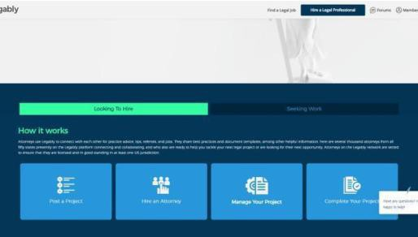Developed a job market platform in NodeJS with MongoDB and ReactJS
* Created the “Payment Integration” using Chargebee.
* Integrated Stripe API to make payments

https://[www.legably.com/](http://www.legably.com/)

## Advertisement Website

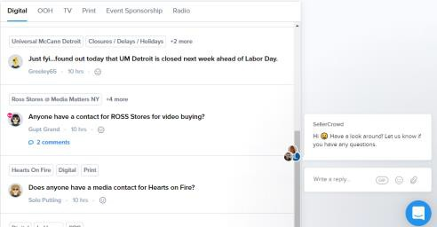I have a project in progress and the client wanted to finish It in urgent. I worked 50 hours a week and completed it in Time. My role was React Full-Stack web developer in this Time.

https://sellercrowd.com/

## NFT MarketPlace

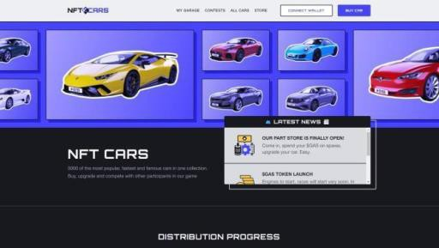NFT Marketplace by Solidity, Web 3. Js and Next.JS. My role was Smart Contract developer as well as web Developer

https://nftcars.me/